DURATION: 2 Hours

THERIC CONTENTS

* Lesson 2. Algorithms.
* Lesson 3. Data Types.
* Lesson 4. Operators and Expressions.
* Lesson 5. Input and Output.
* Lesson 6. Flow Control Selection.
* Lesson 7. Flow Control Repetition.

GITHUB CLASSROOM ASSIGNMENT

https://classroom.github.com/a/0NENxqzv

PROPOSED EXERCISES

Exercise 1. Design and implement a program in C that calculates the average of set of integer numbers inputted by the user until the user inputs the 0 value.

Examples of execution:

Exercise 2. Design and implement a program in C in which the user enters his/her sex (‘M’ or ‘F’) and his/her age (values between 1 and 18) and the program validates them. If the sex or age are incorrect values, then a message is displayed and a new value is required by the program.

Exercise 3. Design and implement a program in C that displays all divisors of an integer number, which must be given by the user.

Exercise 4. Design and implement a program in C that reads one number and returns its factorial.

Example: if the read number is n, then factorial of n(n!) is n*(n-1)*(n-2)*(n-3)*…*1

Exercise 5. Design and implement a program in C that displays the following menu:

CALCULATOR

--------------------

1. Exit
2. Add
3. Subtract
4. Multiply
5. Divide

The program must read the choice made by the user (0, 1, 2, 3 or 4). If the input is 1, 2, 3 or 4, the program has to ask two operands and show the result according to the selected operation. If the input is zero, the program has to end. If the input is any other value, then the program has to ask a new choice. Once the result is shown, clear the screen and show the menu again.

|  |  |
| --- | --- |
|  |  |

Exercise 6.Design and implement a program in C that displays a conversion table from "Euros" to "Pesetas". The table should consist of a sequence of values ordered from lowest to highest. The minimum and maximum value, and the difference required between consecutive values in the table, must be given by the user. Consider that 1 "Euro" equals 166.386 "Pesetas", and the input values are given in "Euros".

Example: in the following conversion table: 2.00, 4.2 and 0.2 correspond to: the minimum value, the maximum value, and the difference between consecutive values, respectively.

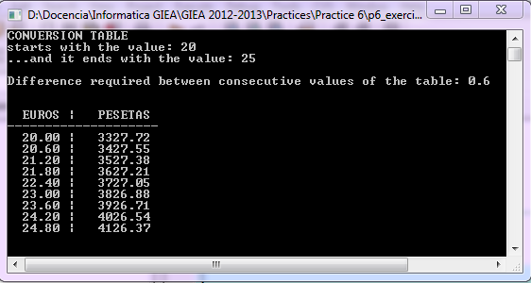

Exercise 7.Design and implement a program in C that reads one number and then, display

1. Sum of odd numbers between 1 and the given number and
2. Sum of even numbers between 2 and the given number.

Example

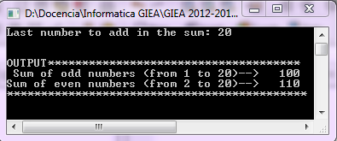

Exercise 8.Design and implement a program in C that reads marks of students until the user enters a negative value. The program must display:

1. Average value corresponding to the given marks.
2. Minimum mark.
3. Maximum mark.

Example

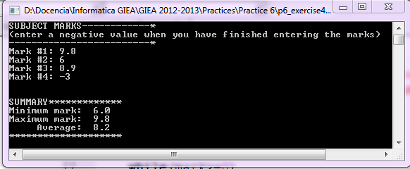

|  |  |
| --- | --- |
|  |  |

Exercise 9.Design and implement a program in C that reads an integer and displays if such number is prime or not.

Example

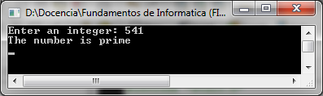

Exercise 10.Design and implement a program in C that computes and displays the following summations:

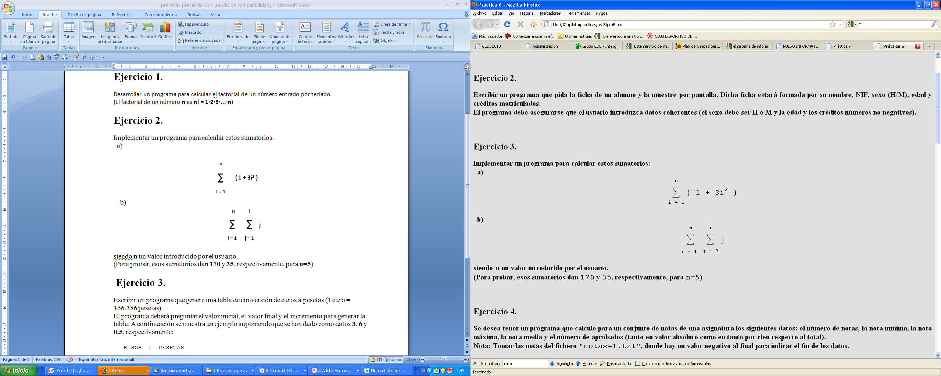

Consider **n** is given by the user.   
(You may test your program by entering **n=5**. In that case, 170 and 35 should be the results of first and second summation, respectively.)

|  |  |
| --- | --- |
|  |  |

Exercise 11.Design and implement a program in C in which the file **"marks.txt"** contains the marks that students have obtained in a subject. Considering the content of this file, write a C program that displays the following information:

1. Minimum mark**.**
2. Maximum mark.
3. Number of students that have passed the subject.
4. Average mark.
5. Number of students that have obtained a mark higher than the mark average.
6. Number of students that have obtained a mark lower than the mark average.

|  |  |
| --- | --- |
| http://www.enlaescuelademabel.com/wp-content/2009/04/20070129152100-portfolios.jpg | **ADD TO PORTFOLIO** |

Exercise 12.Design and implement a program in C that create the following figure in function o N number that indicates number of ‘*’ in each line and L number that indicates the number of lines.

